Machine Learning and Neural Networks
How Kernels Choice Shapes Decision Boundaries in Support Vector Machines
Name: Oluwapelumi Salako | Student ID: 24162709
INTRODUCTION
Support Vector Machines (SVM) are a powerful class of supervised learning algorithms which are widely used for classification tasks. they're effective because of their ability to construct decision boundaries that maximize the margin between classes, thereby improving generalization performance. one of the advantages of SVMs is their ability to handle both linearly and non-linearly separable data using kernel functions.
This tutorial shows how different kernel choices i.e. linear, polynomial, and radial bias function (RBF) influence decision boundaries and model behaviour. I’ve made use of both a synthetic and real-world dataset to analyse how kernel selection interacts with data structure. additionally, we'll explore the effect of gamma hyperparameter in the RBF kernel to demonstrate how model complexity influences underfitting and overfitting

Support Vector Machines and Kernels
Support Vector Machines aims to identify an optimal separating hyperplane that maximises the margin between classes. in a two-dimensional space, it corresponds to a line that separates the data while remaining as far as possible from the nearest points, known as support vectors.
A lot of datasets are not linearly separable, and to address this, SVMs use kernel functions to indirectly map data into higher-dimensional spaces. this process is known as the kernel trick, and it allows complex relationships to be modelled without directly computing the transformation.
Different kernels impose different assumptions on the data. Linear kernel assumes the data is approximately linearly separable, while the polynomial kernel introduces curved decision boundaries and RBF kernel produces highly flexible boundaries capable of modelling complex structures. This implies that the choice of kernel directly affects model performance and generalisation.

Dataset Used
Two datasets were used to evaluate SVM kernel behaviour.
The first dataset, make_moons, is an artificially generated dataset designed to create two intertwined crescent shapes that's not linearly separable which makes it useful for demonstrating the limitations of linear models, while the second dataset is the iris dataset, a well-known real-world dataset used for classification tasks, which contains iris flower measurements and is commonly used as a machine learning benchmark. For visual clarity, only two features and two classes were used from the dataset for the purpose of the tutorial.
The Iris dataset is made publicly available through the link below:
https://www.kaggle.com/datasets/uciml/iris
By combining synthetic and real_world datasets, the tutorial provides a more comprehensive evaluation of kernel behaviours across different conditions.
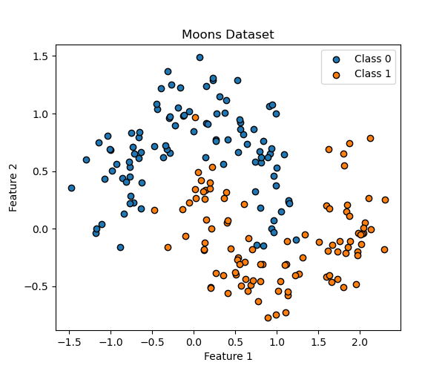

Figure 1: Distribution of the make_moons dataset showing non-linear class structure.

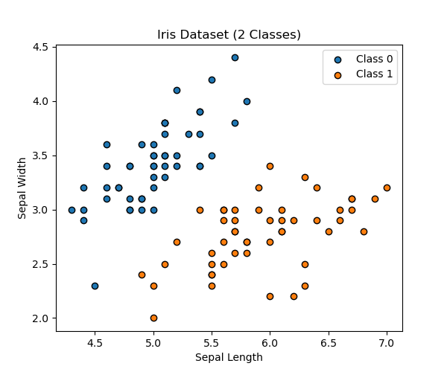

Figure 2: Distribution of the iris dataset (two classes), showing more structured and near-linearly separable pattern.

Kernel Comparison on Synthetic Data
The performance of different kernels is first evaluated using the make_moons dataset. It is observed that the linear kernel performs poorly due to its inability to compute non_linear patterns, which results in significant misclassification, while the polynomial kernel improves performance by introducing curvature into the decision boundary which allows for a better approximation of the data structure.

The RBF kernel produces the most accurate classification, because it generates a flexible boundary that closely follows the shape of the data. This demonstrates the importance of non-linear transformations when working with complex datasets.

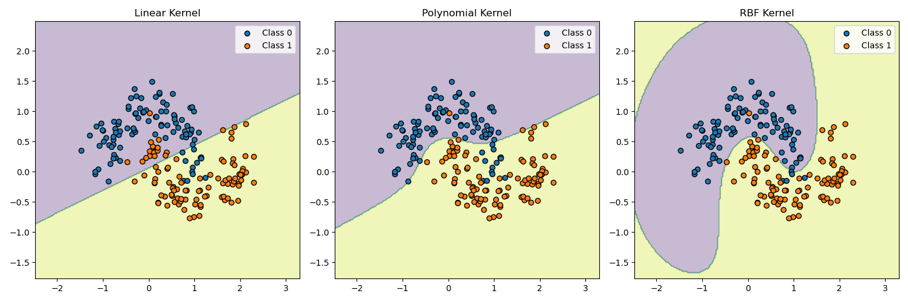

Figure 3: Comparison of decision boundaries produced by linear, polynomial, and RBF kernels on the make_moons dataset.

Kernel comparison on Real-World Data
When applying the same kernels to the real-world dataset (Iris dataset), the results are significantly different from those observed with the artificially generated dataset.
The linear kernel performs well, which indicates that the dataset is approximately linearly separable. in this instance, more complex kernels will provide only marginal improvements. The polynomial and the RBF kernels on the other hand still produce valid decision boundaries, but their additional flexibility is not required, and this highlights the principle that increasing model complexity does not necessarily improve its performance, particularly when the underlying data structure is simple.

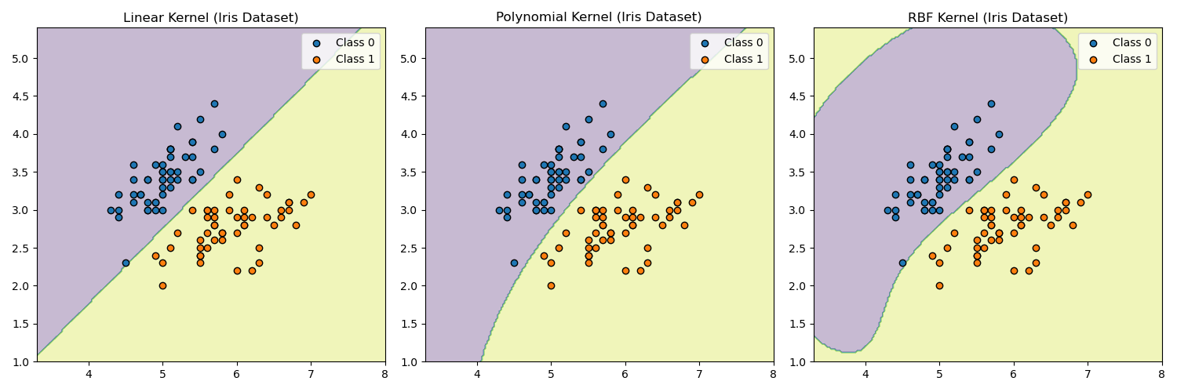

Figure 4: Kernel comparison on the iris dataset, demonstrating improved performance of simpler models on structured data.

Effect of Gamma on the RBF Kernel
The gamma parameter plays a crucial role in controlling the behaviour of the RBF kernel. it determines the range of influence of individual data points, effectively controlling model complexity.

At low gamma values, the model produces a smooth and overly simplified boundary, resulting in a case of underfitting. the model fails to capture the underlying structure of the data. the model achieves a balance between flexibility and generalisation at moderate gamma values, thereby producing and appropriate decision boundary.
at high gamma values, the model becomes highly sensitive to individual data points, which results in a complex and irregular boundary. while this may improve training accuracy, it can often lead to overfitting and poor generalisation.

This behaviour reflects the broader bias-variance tradeoff, where increasing model complexity reduces bias but increases variance.

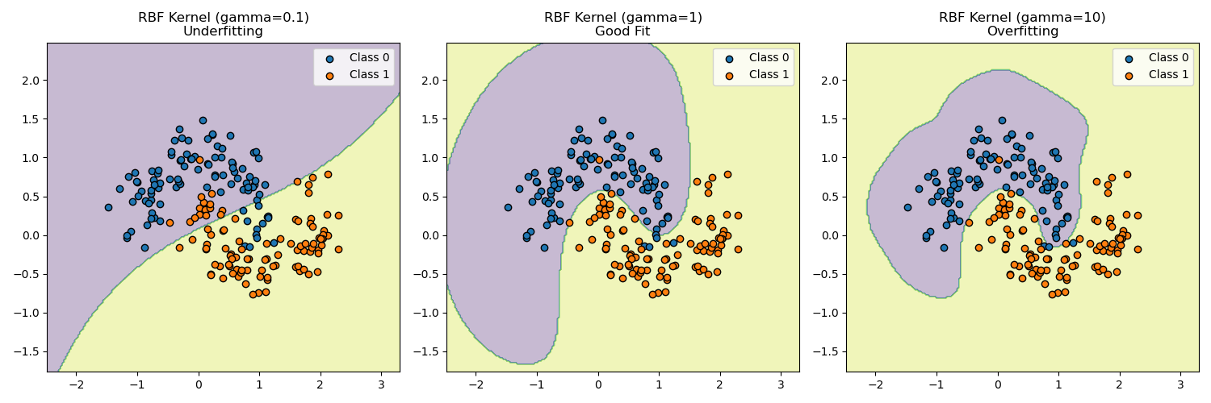

Discussion
The results demonstrates that kernel selection is not a uniform decision, instead, it must be guided by the characteristics of the dataset. For highly non-linear datasets, flexible kernels like RBFs are essential while for simpler datasets, linear models may offer comparable performance with reduced computational complexity and improved interpretability.

Additionally, hyper parameters like gamma play a crucial role in controlling model behaviour, and poorly chosen values can lead to overfitting or underfitting, which emphasizes the importance of model tuning.

Conclusion
This tutorial has demonstrated how SVM kernels influence decision boundaries and model performance across different datasets. By comparing linear, polynomial, and RBF kernels, we have shown how model flexibility impacts classification outcomes.
The analysis of the gamma parameter further highlights the importance of balancing model complexity and generalisation. these findings reenforces the idea that effective machine learning requires understanding algorithms but also understanding the data to which they are applied

Accessibility
Colour-blind friendly visualisations and clear labelling were used to ensure accessibility of all figures produced

